1. **What are three conclusions we can make about Kickstarter campaigns given the provided data?**

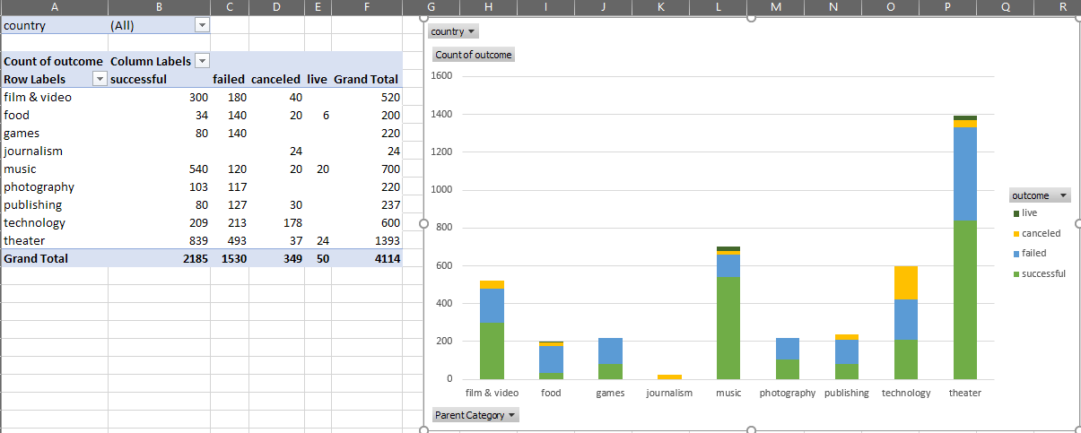

From the above graph, one conclusion we can make about the Kickstarter campaigns within the provided data is how some categories are much more successful than others. For example, projects related to Film/Video, Music, and Theater are much more likely to reach their funding goals as opposed to Food, Games, and Journalism. Interestingly, despite the Theater category having the most successful projects within the data, it’s the Music category that has had the most success on a percentage basis given the data provided.

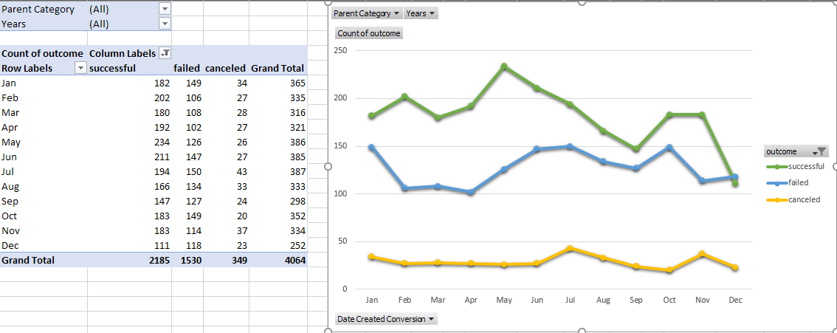

Another conclusion we can make about the Kickstarter campaign data is how a project’s successfulness is related to the time of year in which the funding is live. Project’s are much more likely to meet their goals in the beginning of the year, especially in May, compared to the end of the year, like December. This conclusion is also further supported by the fact that the success rates drop after May despite the rates of project’s being canceled staying relatively similar throughout the year.

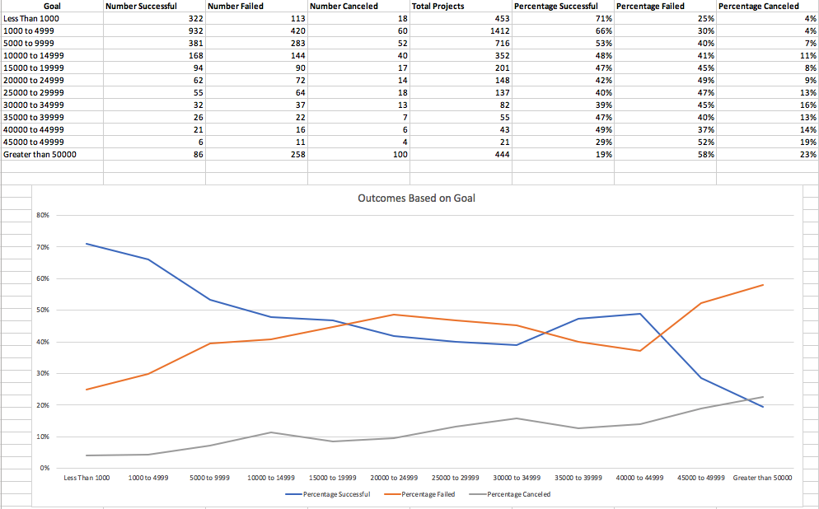

A third conclusion we can make from the provided Kickstarter data is how a project’s success can depend on the campaign’s funding goal. Project’s that only require less than $5,000 in funding are much more likely to succeed compared to those that desire greater than $50,000. It is interesting to note in the chart above how success and failure rates seem to plateau between $10,000 to $40,000, but the canceled rates continually increase given the larger required goal of the campaign.

1. **What are some of the limitations of this dataset?**

When dealing with datasets like these where only 4,115 campaigns out of more than 300,000 that have been created, there are several limitations to the data that should be considered. Firstly, small studies can produce false-positive results, or they over-estimate the magnitude of what the provided data has shown. For example, this dataset shows how successful Music and Theater campaigns have performed, but they also account for more than half of the project’s analyzed compared to the seven other categories within this dataset. In contrast, it would be interesting to see how additional Journalism projects performed rather than those in the data that all resulted in cancelation.

A second limitation to consider would be how the timing of the campaign’s being analyzed are in relation to each other. Social trends can play a major role in the popularity of Kickstarter projects potentially becoming successful. For example, it’s not very surprising to see Journalism projects struggle to the degree that they did within the dataset due to society’s reliance more on social media or online information for news rather than traditional means that used to be much more popular.

Another limitation that immediately came to mind was what type of background did the individual who began the project possess. While campaign’s that would only require less than $5,000 were much easier to successfully complete given the data, what type of support did projects requiring more than $20,000 need outside of the current dataset? When looking at the data it is interesting to note how almost half of the projects that possessed the highest average donation still failed to meet their goal.

1. **What are some other possible tables/graphs that we could create?**

One table or graph that I feel would be interesting to analyze would be how Kickstarter project’s performed in different countries. It’s safe to assume that a majority of the campaign’s created through Kickstarted originated within the United States, however I feel it would be intriguing to see how successful other project’s around the world would compare if the dataset was larger. However, one issue with the provided data is that the amount of funding received per campaign are not all of a similar currency which does affect the accuracy of the results displayed when trying to make proper conclusions.

A second table that would provide better insight into analyzing Kickstarter project’s given this dataset would be a more in-depth look into how average donations per project affect the successfulness of a campaign. This would become even more interesting when comparing projects across all available categories. As evidenced by the other graphs in this assignment, there’s clearly more data included on certain categories compared to others and if those overall numbers became closer it would be interesting to see what results the data would show.

One last graph to possibly observe would be the relationship between “Staff Picks” and the “State” of a project. This is not a graph I would rely upon for any sort of constructive analysis given the complete lack of information on which or how many individuals were included within that column in the data, however it would be interesting to calculate how correct they were in their predictions.